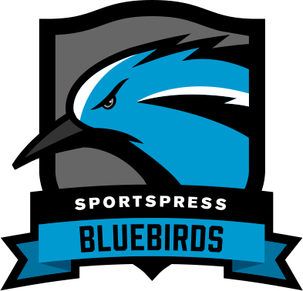

Team Name

Sponsorship Package

1. Team Profile
The first item on the list is to present your team’s profile. Consider including the following information:

- When your team was founded
- Total number of members
- The size of your audience (think social media followers, email list, fan club members), Any significant achievements, awards or individual player performance stats.
- Information about your website, such as the number of monthly visitors and pageviews
- Any media coverage

2. Sponsorship Requirements
List the requirements that your sponsors should meet. This can include:

- Financial contributions that will be used to buy new equipment or reserve a venue for an upcoming season or match
- Cost of traveling to tournaments or marketing costs
- Events your want to organize or participate in

3. Sponsor Benefits
In this section, include a list of benefits that your sponsor will receive. A list of benefits can include:

- Increased brand awareness
- Exposure to new demographics
- New referral customers because of an exclusive discount code

4. Define the Scope of the Package
Define the scope of your package. Here, you can include the plans and packages you offer as well as methods to achieve benefits outlined in the previous section. You’ll also want to list your Terms and Conditions which include cancellation, refund, and renewal policy, the agreed duration, and more.

5. Success Metrics
When it comes to sponsors, the metrics will be split into tangible and less tangible results. If their audience size increased or if their sales figures went up as a result of sponsoring you, those metrics are tangible and easily measured results.

Less tangible results, on the other hand, include examples such as increased brand awareness, an increase in customer loyalty, brand perception among a new audience demographic, and more.

Once you and your potential sponsor agree on what type of metrics you’ll use, use this section to document how you will measure them.

6. Call to Action
Here, include the following:

- Your contact details such as email, mobile phone, social media handles, and website address
- An invite to attend your match or event
- A brief thank you note and a link to your Sponsors’ page on your website

